Sleep Coach Study – Round 2 Results

**Study Premise:** I created a device to try to help people fall asleep faster. I found several people willing to try the device and provide me data on their sleep via a daily survey and seep tracking smartphone app. I had the users record data for 3 weeks without the sleep coach, and I then sent the users the sleep coach device and had them record data for 3 weeks of sleep using the device.

**Device Details:** The Arduino-based device produces adjustable high-intensity light that can shine through your eyelids in a sinusoidally increasing and decreasing pattern of brightness with a period that lengthens over time. You match your breathing up with the intensity of the light, and over time your breathing slows.

The big problem I found with similar smartphone apps is that you need to have your eyes open to see the light, and most people do not try to get to sleep with their eyes open. I’ve designed the device to be adjustable to obtain the ideal angle of light from the nightstand to the eyes, and the max brightness is adjustable. The device is in an alpha state, meaning it isn’t pretty, but it gets the job done.

Results

User 1:

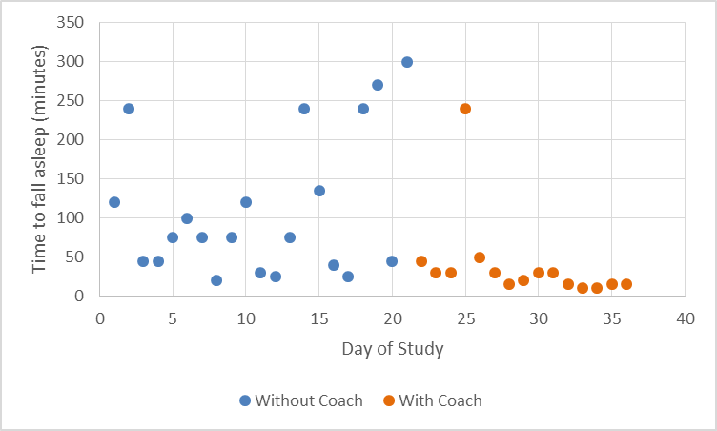

Average time to sleep without sleep coach: 111 minutes.

Average time to sleep with sleep coach: 39 minutes (25 minutes with outlier removed).

User Thoughts: “I think the quality of sleep has been improving, and I think that's the sleep coach.”

User 2:

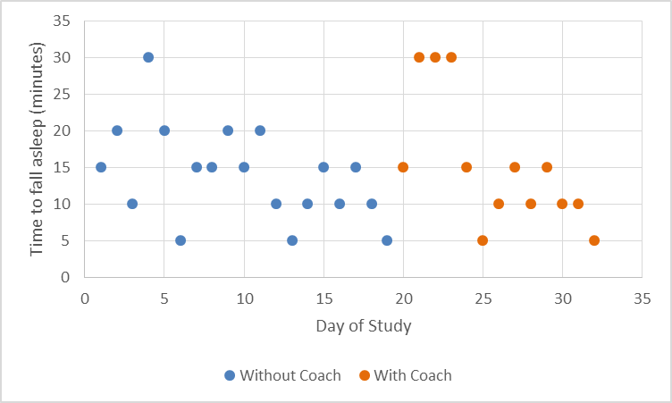

Average time to sleep without sleep coach: 21 minutes (14 minutes with outlier removed).

Average time to sleep with sleep coach: 15 minutes.

User Thoughts: “I was really impressed with the sleep coach- it cut the amount of time it took me to fall asleep by about half.”

User 3:

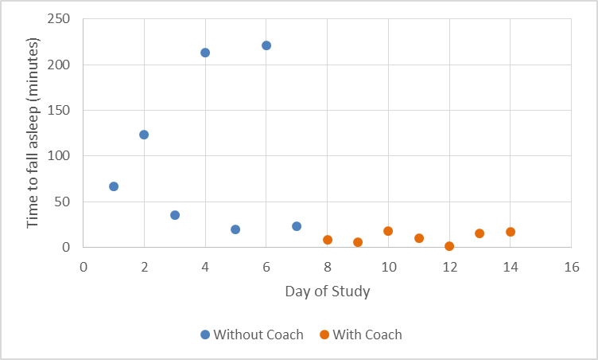

Average time to sleep without sleep coach: 100 minutes

Average time to sleep with sleep coach: 11 minutes.

Note: this user only provided 2 weeks of data.

New user data as of 5/25/13:

User 4:

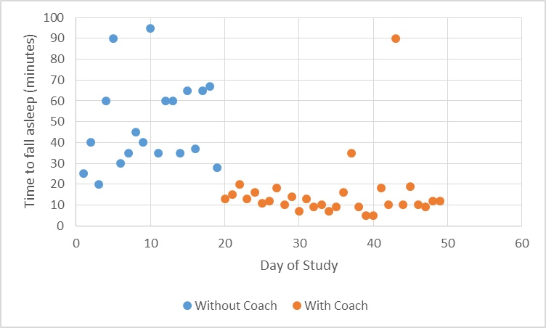

Average time to sleep without sleep coach: 49 minutes

Average time to sleep with sleep coach: 15 minutes (12 minutes with outlier removed).

User Thoughts: “When I am able to settle down and get in bed at a decent hour, the sleep coach helps immensely in allowing me to fall asleep in an acceptable amount of time. Usually I get incredibly distracted and it can take an hour, sometimes many hours, to fall asleep. The sleep coach allows me to fall asleep in at least under 30 minutes, sometimes even as few as 7 minutes, which is great for me! I would definitely recommend this device to anyone who is on the search for something new to help them fall asleep, someone who perhaps has tried every other sleep aid without finding anything that truly helps yet. The Sleep Coach is awesome!”

User 5:

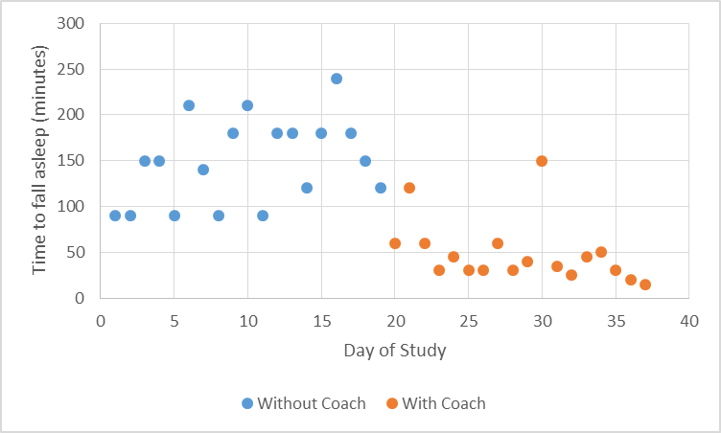

Average time to sleep without sleep coach: 149 minutes.

Average time to sleep with sleep coach: 49 minutes.

User Thoughts: “I've noticed a HUGE decrease in how long it takes me to fall asleep which has been wonderful! I really like the machine. It's easy to use and works well. I was worried I might not be able to see the light or that if I could it might trigger my migraines, but I can see it with no headaches caused by it. I was also expecting it to be huge for some reason, so I was pleasantly surprised by the compact size.”

Conclusion

Similar to the last time I performed the study, actually getting data from volunteers was challenging. This time I sent out 5 sleep coaches and got reasonable data sets from 2 participants, making the total study participant count 5.

User 1 showed great improvement, and I got lots of data from this user so I can say fairly confidently that the sleep coach has improved this user’s time to fall asleep.

User 2 showed little to no improvement from the sleep coach over the 2 weeks of the study, but there is a slight trend showing that time to fall asleep may have been less for the second week indicating that the user may have been getting used to the sleep coach during the first week of use. The user feels as though their sleep has improved greatly.

User 3 showed great improvement, but the data set is quite limited. Since all data is user reported, there is no way to tell if the data is truthful or not.

User 4 showed great improvement and provided the most complete data set. This user reports that they will continue to use the sleep coach to help them fall asleep.

User 5 has had serious problems falling asleep, and the data shows that the sleep coach has helped this person consistently fall asleep faster.

Overall, the data is still promising. One thing that I have noticed is that the sleep coach seems to add consistency to participants’ time to fall asleep. Most of the users were all over the place with time to fall asleep before using the coach, and the sleep coach seems to give them a more consistent window of time in which they will fall asleep. I will continue to try to gain study participants. The switch to google forms for the surveys and sleep logs has greatly improved the organization of the study.